# Comprehensive Report on Salesforce Agentforce

## Introduction to Agentforce

Agentforce agents are autonomous, proactive applications designed to execute specialized tasks to help employees and customers. Agents use large language models (LLMs) to analyze and understand the full context of customer interactions or an automated trigger, then reason through decisions on the next steps autonomously.

These agents generate responses that are consistent with your company’s brand voice and guidelines using trusted business data, including Salesforce CRM data, external data from Data Cloud, and more. These agents are capable of operating 24/7 across various platforms like self-service portals and messaging channels, handling tasks proactively within set guardrails. When faced with complex issues beyond their scope, they can escalate the matter to human agents, ensuring that queries are resolved efficiently and accurately.

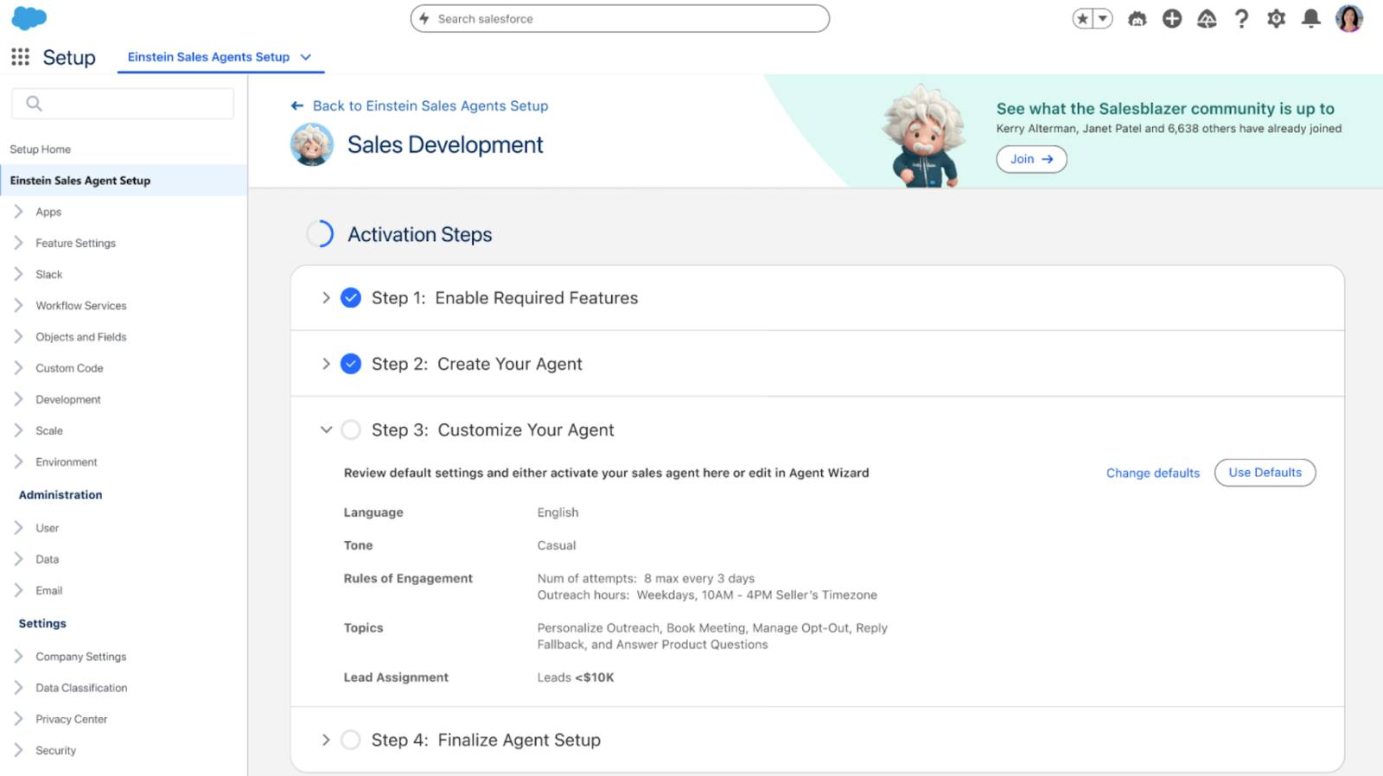

## Key Components of an Agent

Each Agentforce agent has parameters that define the job it can do and the action it can take.

* **Role:** An agent’s purpose. This defines the job to be done and the broader goals the agent should achieve on your team.
* **Knowledge:** The data an agent needs to be successful. This could include company knowledge articles, CRM data, external data via Data Cloud, public websites, and so on.
* **Actions:** The goals an agent can fulfill. This is the predefined task an agent can execute to do its job based on a trigger or instruction. For example, it could run a flow, prompt template, or Apex.
* **Guardrails:** The guidelines an agent can operate under. These can be natural-language instructions telling the agent what it can and can’t do, when to escalate to a human, or could come from built-in security features in the Einstein Trust Layer.
* **Channels:** The applications where an agent gets work done. This can be your website, CRM, mobile app, Slack, and more.

## Agentforce Reasoning Engine, the Brain of an Agent

The Agentforce Reasoning Engine is designed to enhance user interaction through faster, more capable, and more multi-turn conversations. Here’s a brief overview and key features.

* **Multi-turn chat:** The reasoning engine facilitates interactive communication with users by considering and adapting to added conversational context, enhancing the accuracy of the service provided.
* **Topic classification:** The reasoning engine classifies user utterances into topics based on predefined descriptions, ensuring relevant responses.
* **Instructions and actions:** Each topic includes specific instructions and actions, such as verifying order details or obtaining further information, to assist users accurately and efficiently.
* **Knowledge Retrieval:** The reasoning engine uses multiple techniques including advanced retrieval augmentation generation (RAG) which selectively uses multiple language models to iteratively refine the quality of queries, retrieving the most relevant knowledge chunks, while also evaluating the quality of the response.
* **Searchable public data:** Agents can now securely access public data through the Einstein Trust Layer, expanding its knowledge base.

## How an Agent Takes Action

Agents take action and adhere to guardrails using natural language descriptions that outline the tasks and operational boundaries. Here's a summary of how they operate.

* The agent first receives a trigger, which can be a conversation with an employee or customer, a change in data, or an automation.
* The agent uses the LLM and natural language descriptions to identify the context and select a topic that best fits the job to be done, including the scope, data required, and necessary conditions.
* Depending on the task, an agent selects and chains actions. Those actions are executed via flows, apex classes, APIs, or direct prompts.
* Agents dynamically plan and execute tasks while strictly following predefined guardrails. They also have built-in mechanisms for harm and toxicity detection, using the Einstein Trust Layer, ensuring they avoid engaging in inappropriate or harmful activities.

Einstein Setup -= on

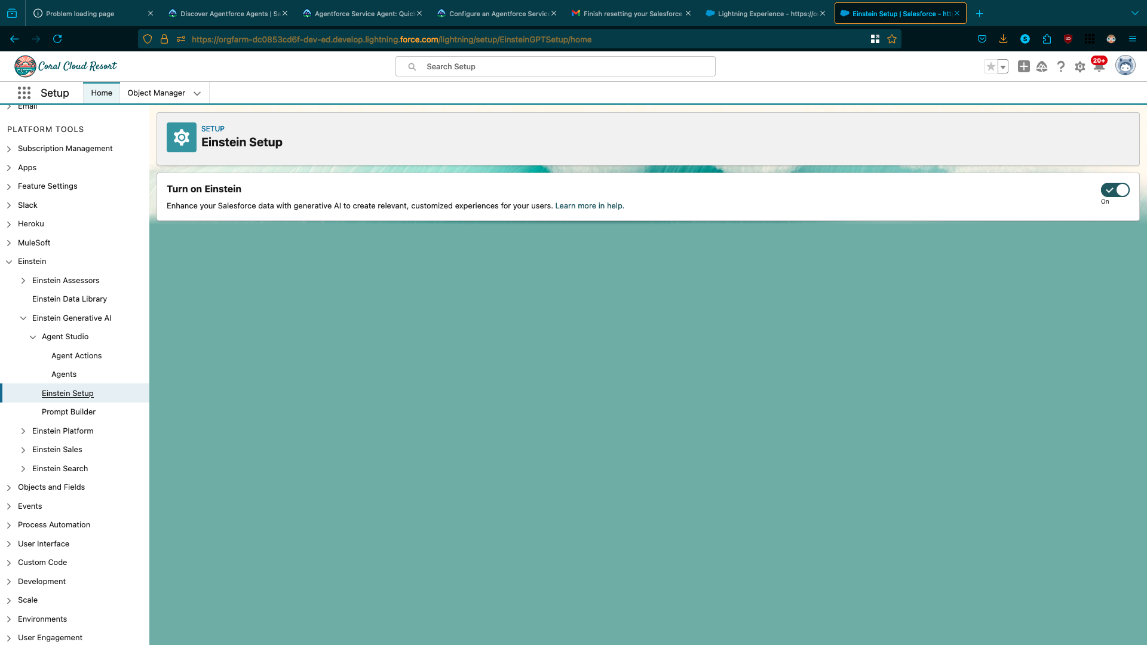

Agent Einstien Copilot Salesforce – on

help your employees accomplish key business tasks with a conversational AI assistant for Salesforce CRM.

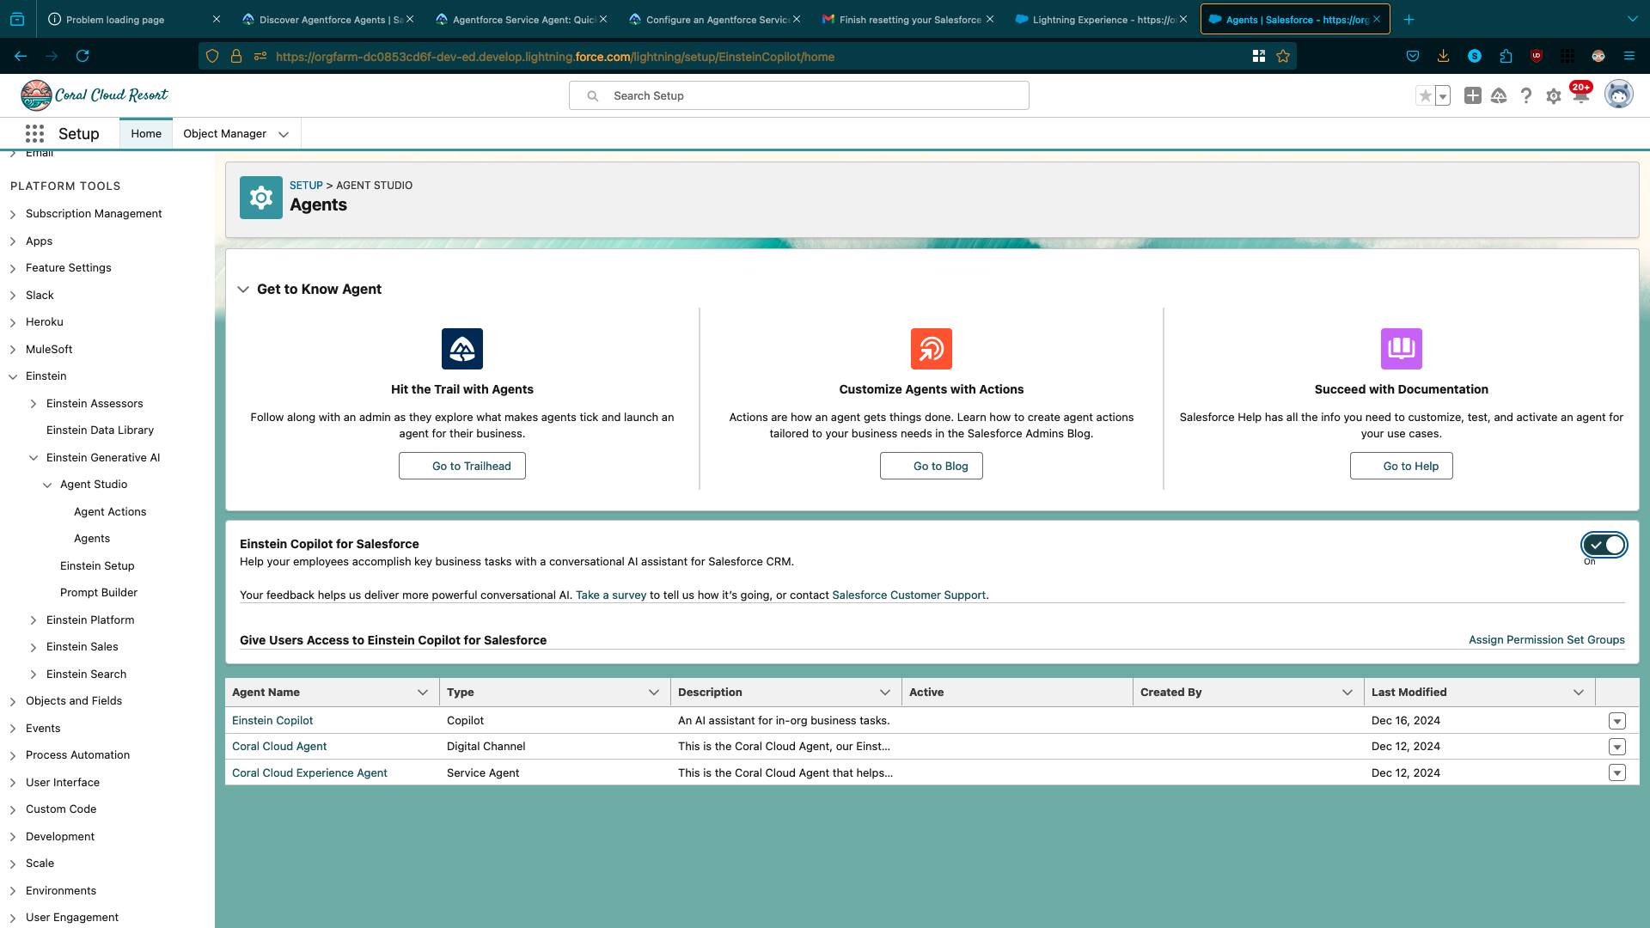

All sites -> pre built file -> Builder -> Publish -> now we follow below steps

### Add a Permission Set to the Agent’s User Profile

The new agent will have a user profile associated with it. However, additional permissions need to be added to this user profile.

1. Search for Users in the Setup Quick Find and select **Users**.
2. Select the **EinsteinServiceAgent User**.
3. Scroll down to the Permission Set Assignments section and click **Edit Assignments**.
4. Select the **Service Agent Permissions** 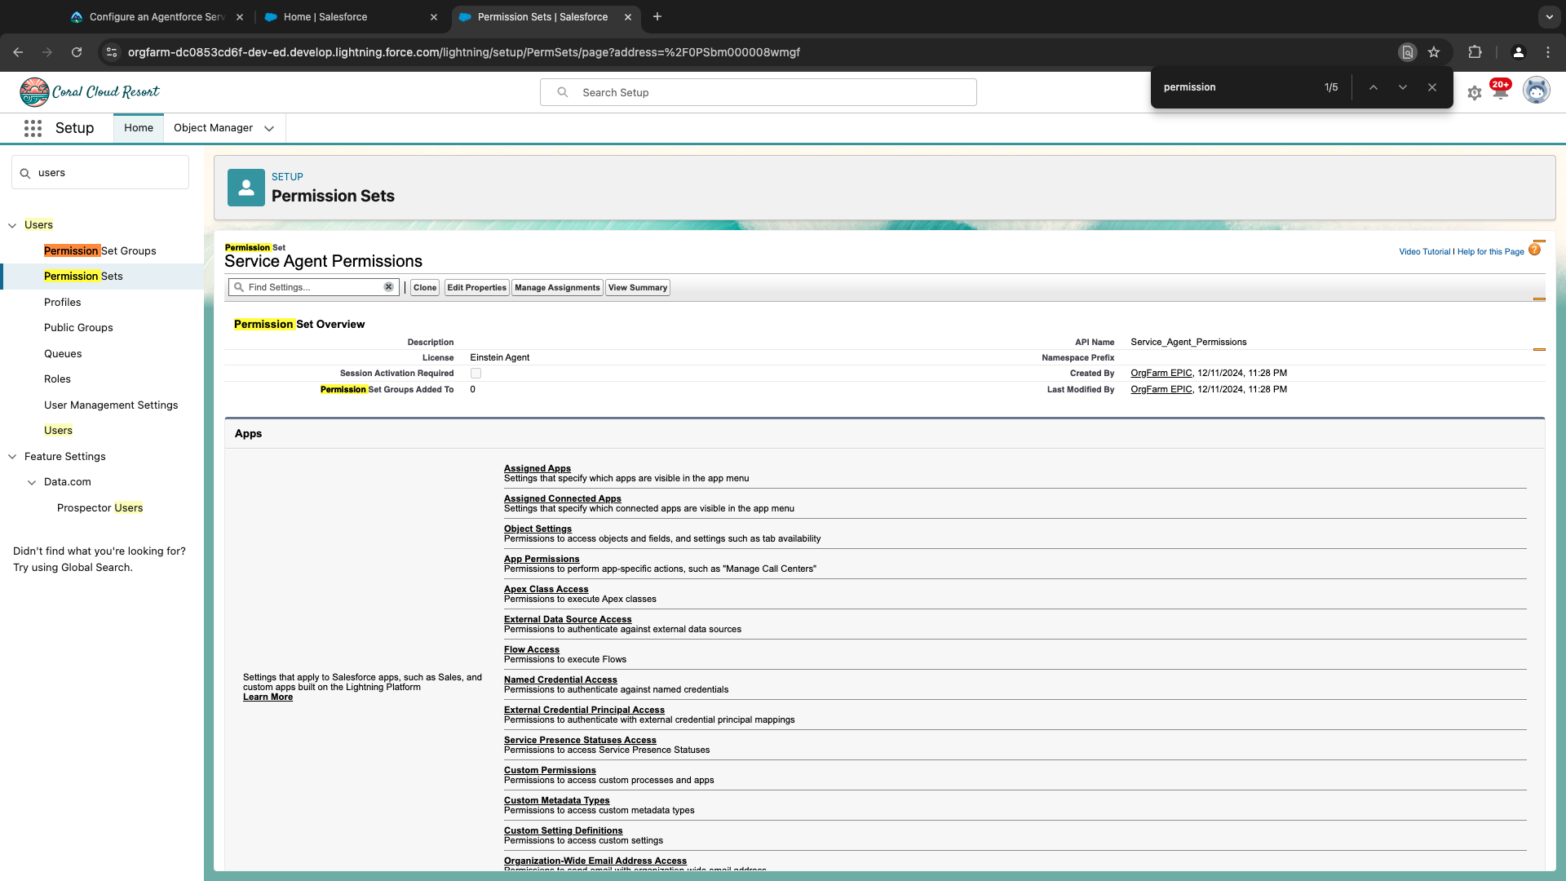

Permission Set and click the **add arrow** to add to the Enabled Permission Sets list.  
Note: There should now be two listings in the Enabled Permission Sets list: Agentforce Service Agent User and Service Agent Permissions.

1. Click **Save**.

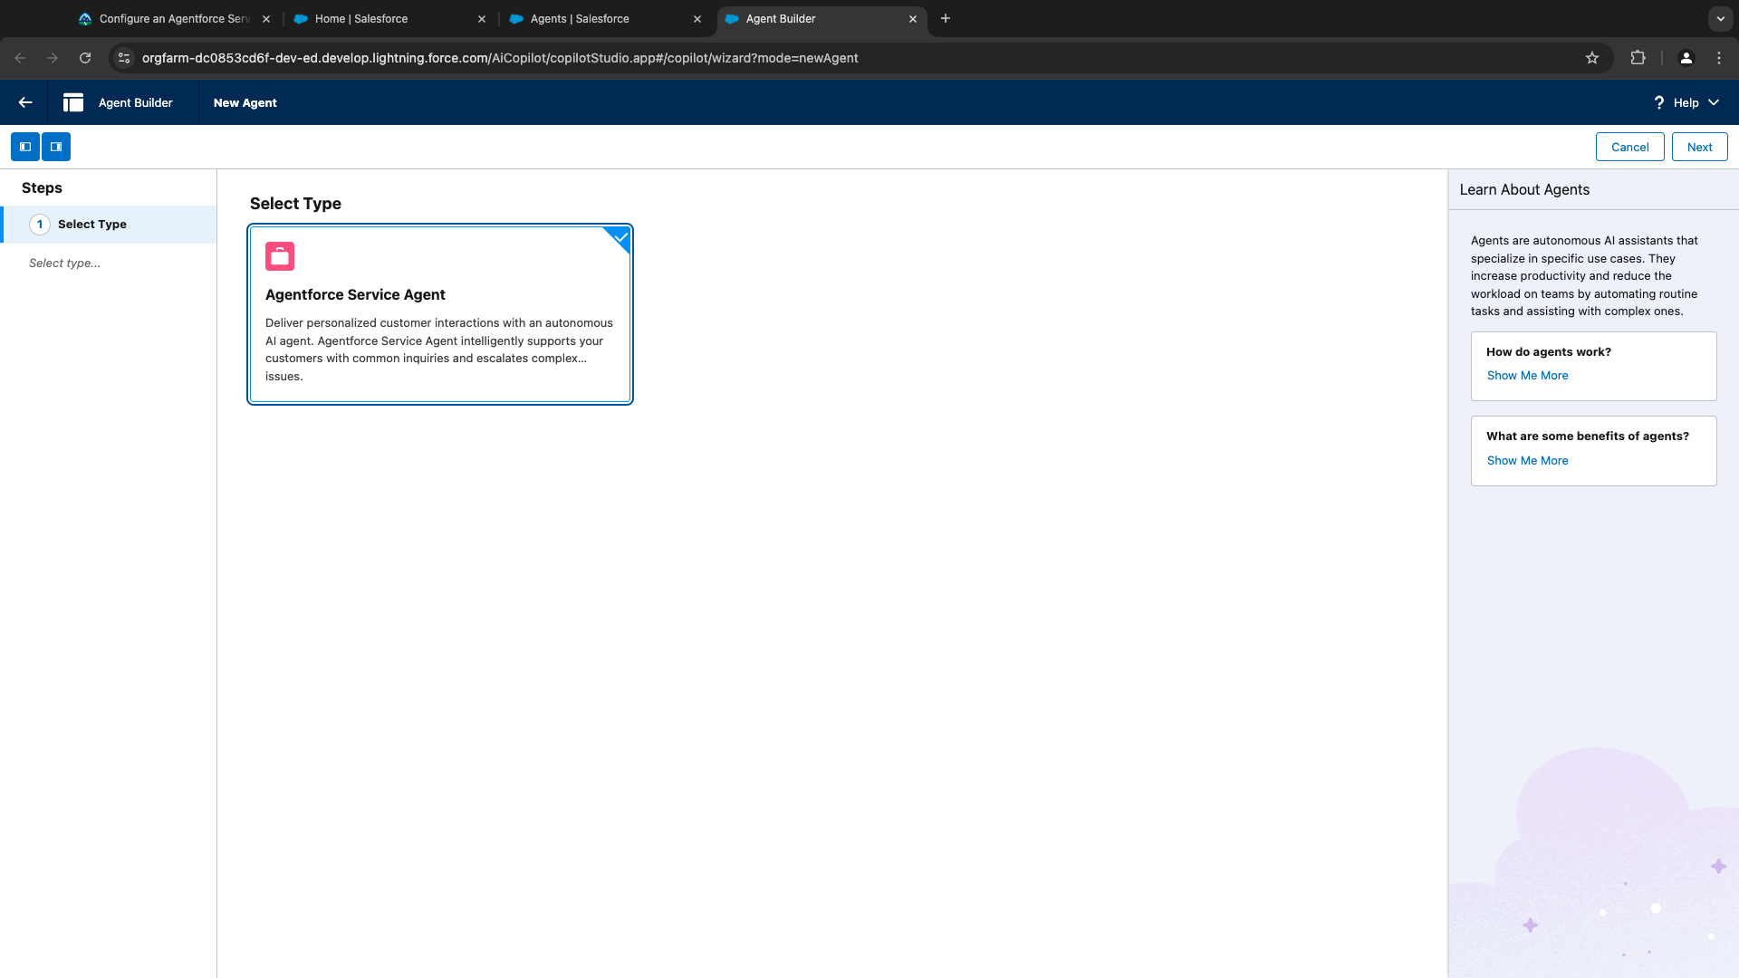

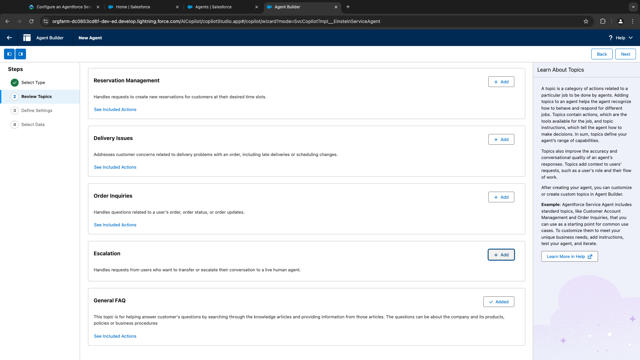

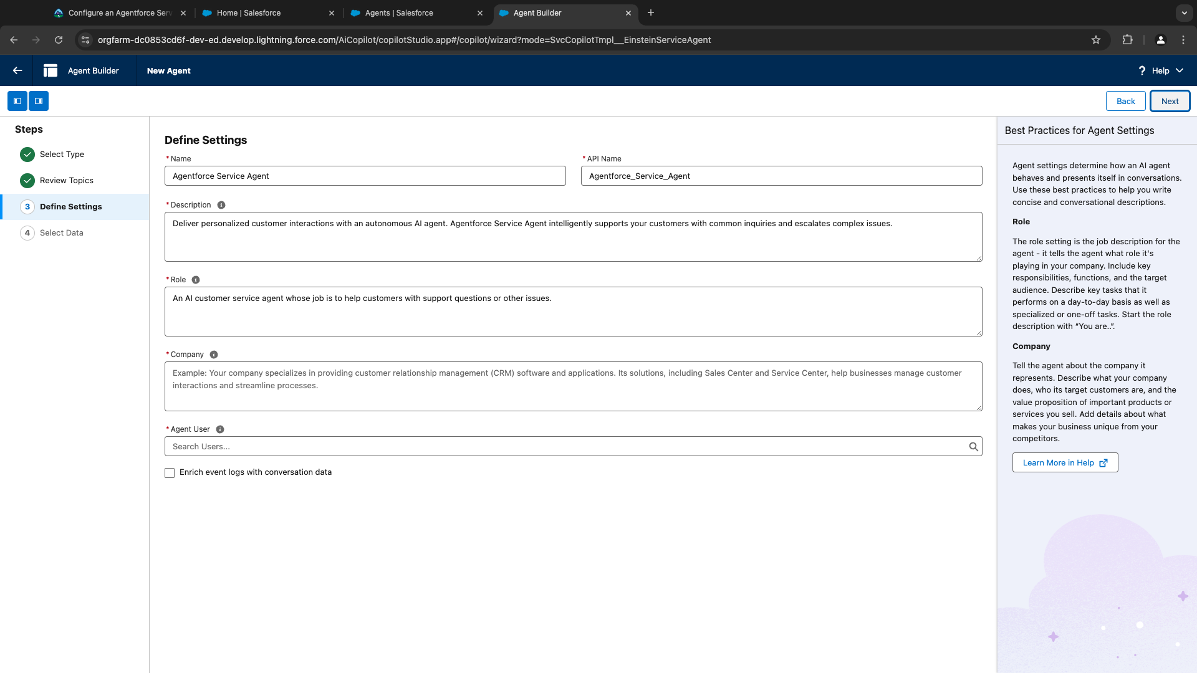

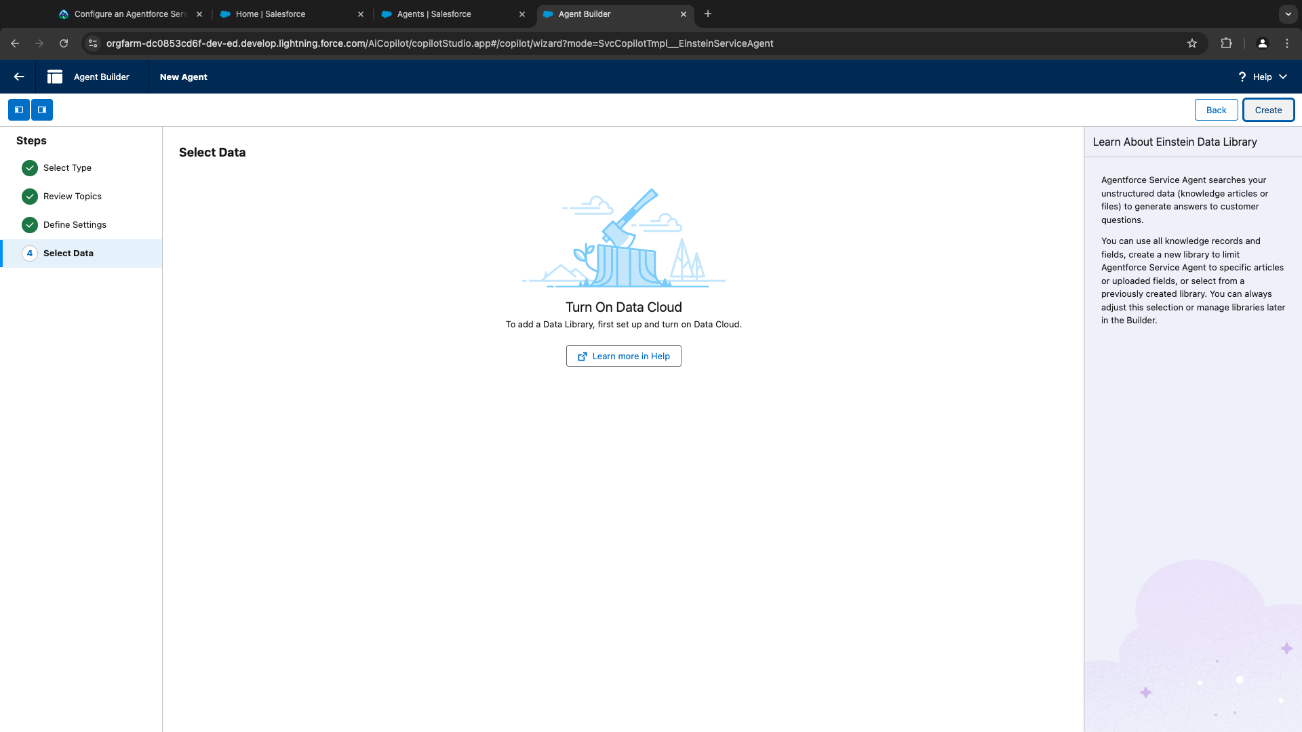

<https://help.salesforce.com/s/articleView?id=sf.c360_a_data_cloud.htm&type=5> (help)

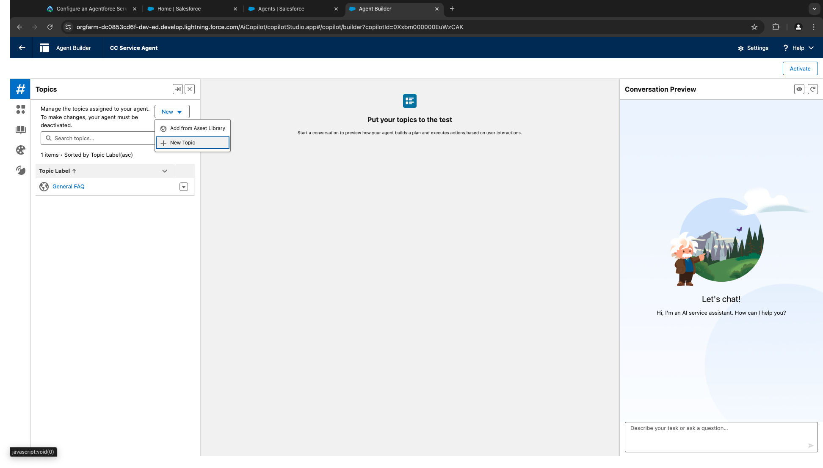

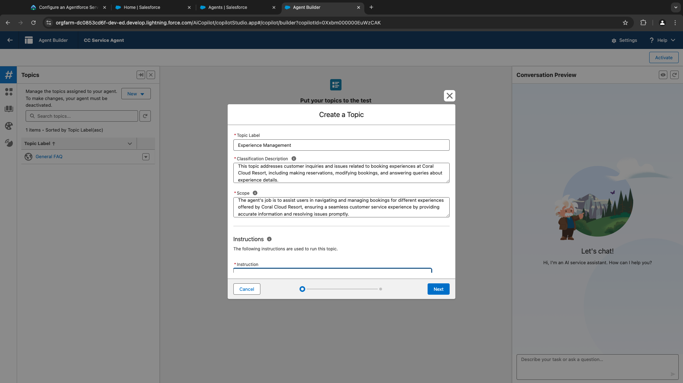

Classification description. - An agent uses this description to determine when to use your topic in a conversation, based on your user’s intent.

The Scope - The scope tells an agent what it’s able to do within your topic.

Instructions - - Instructions help an agent make decisions about how to use the actions in a topic for different use cases.For example, ask an agent to collect clarifying information before running an action. Or tell an agent how to choose between different actions.

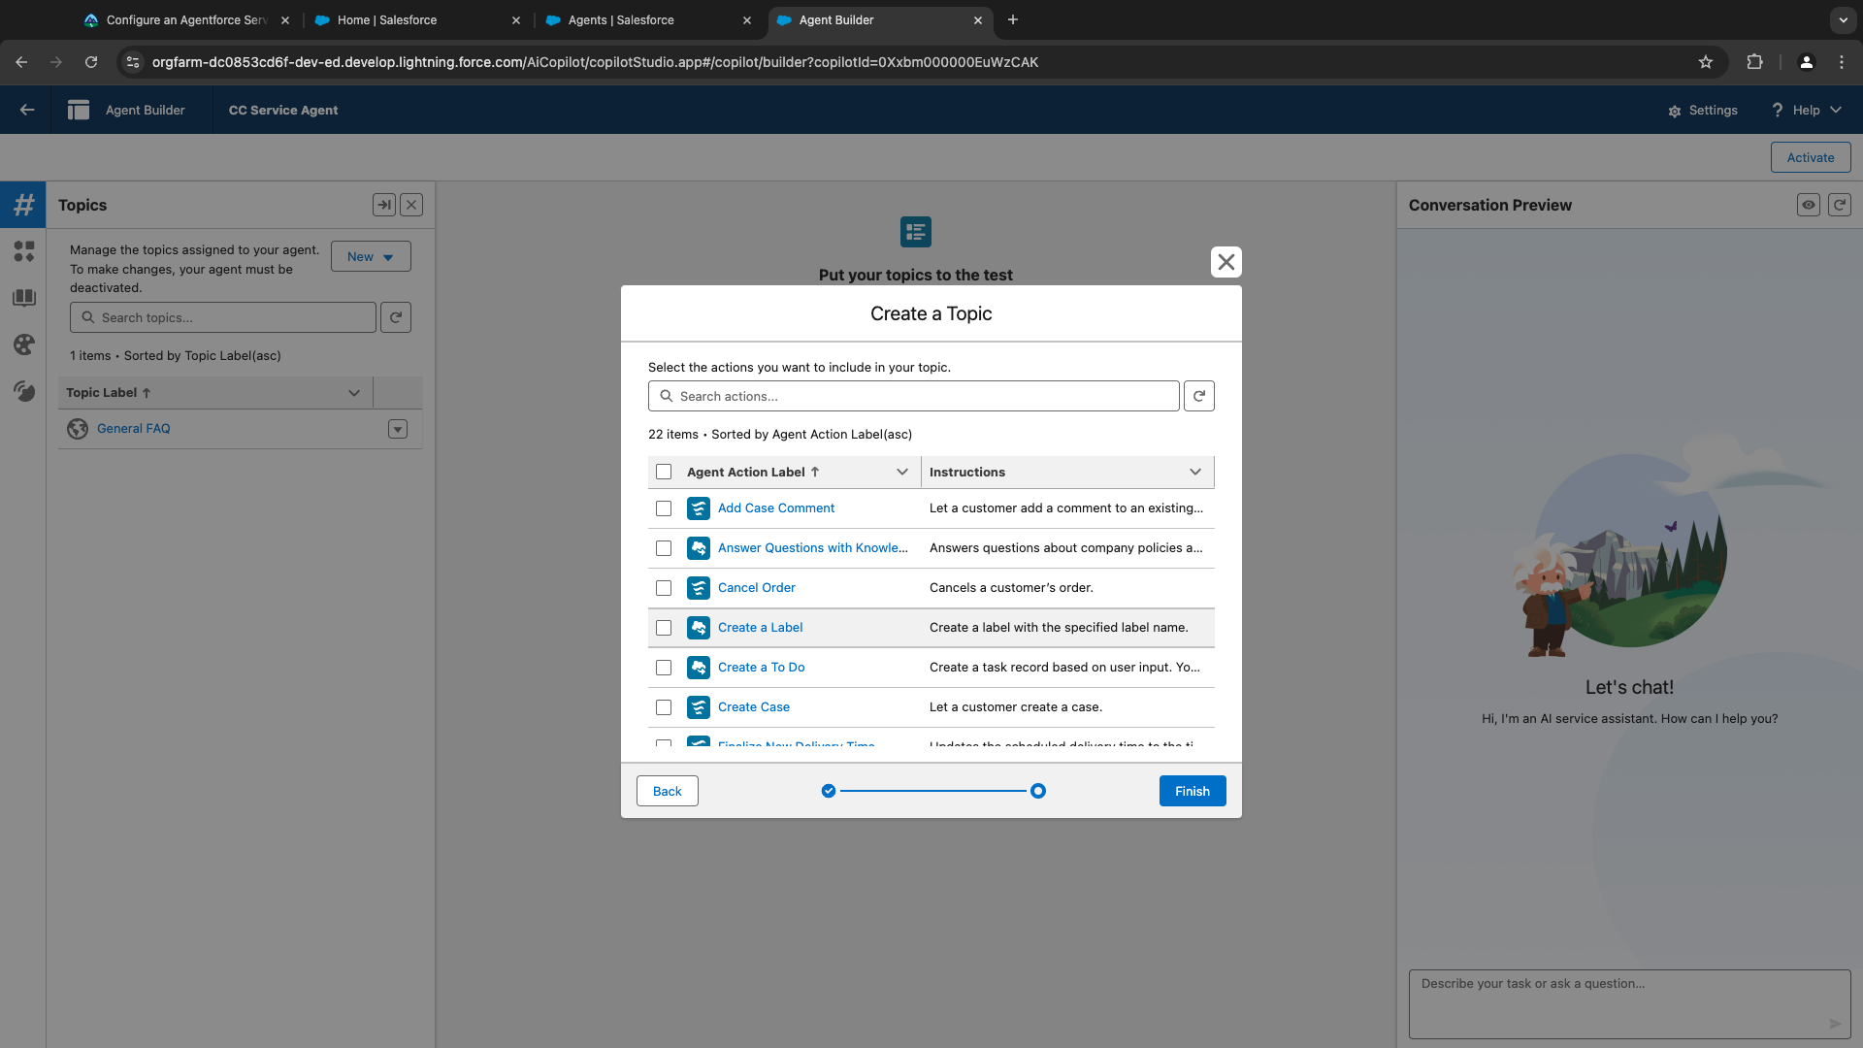

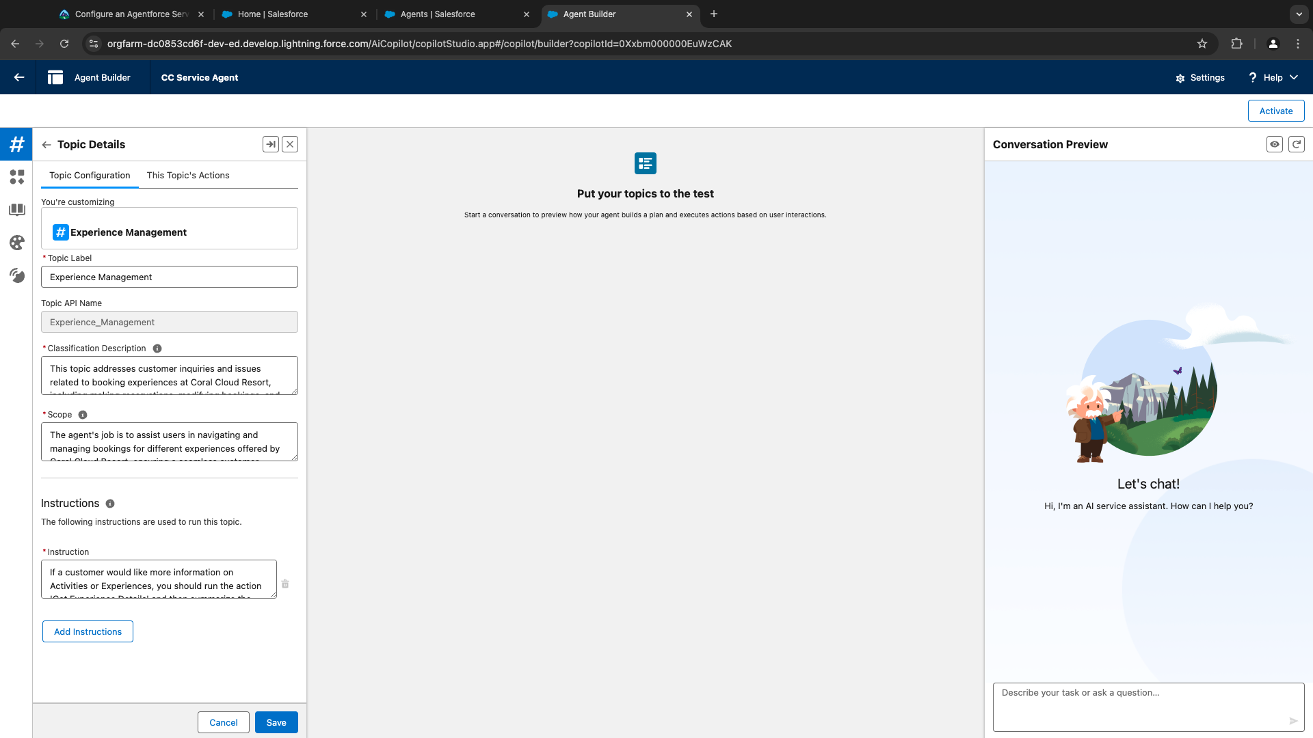

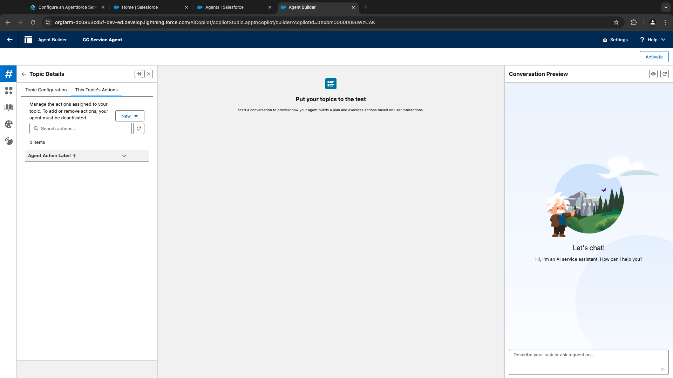

Flow integration - Add Action

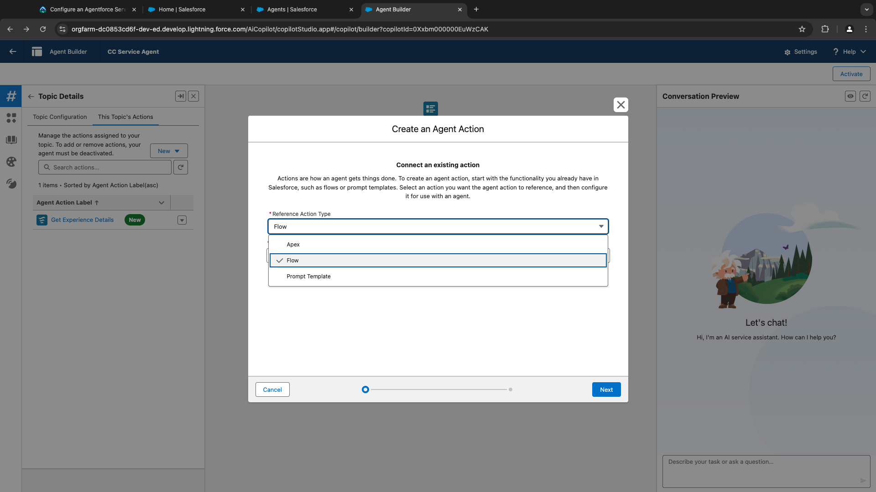

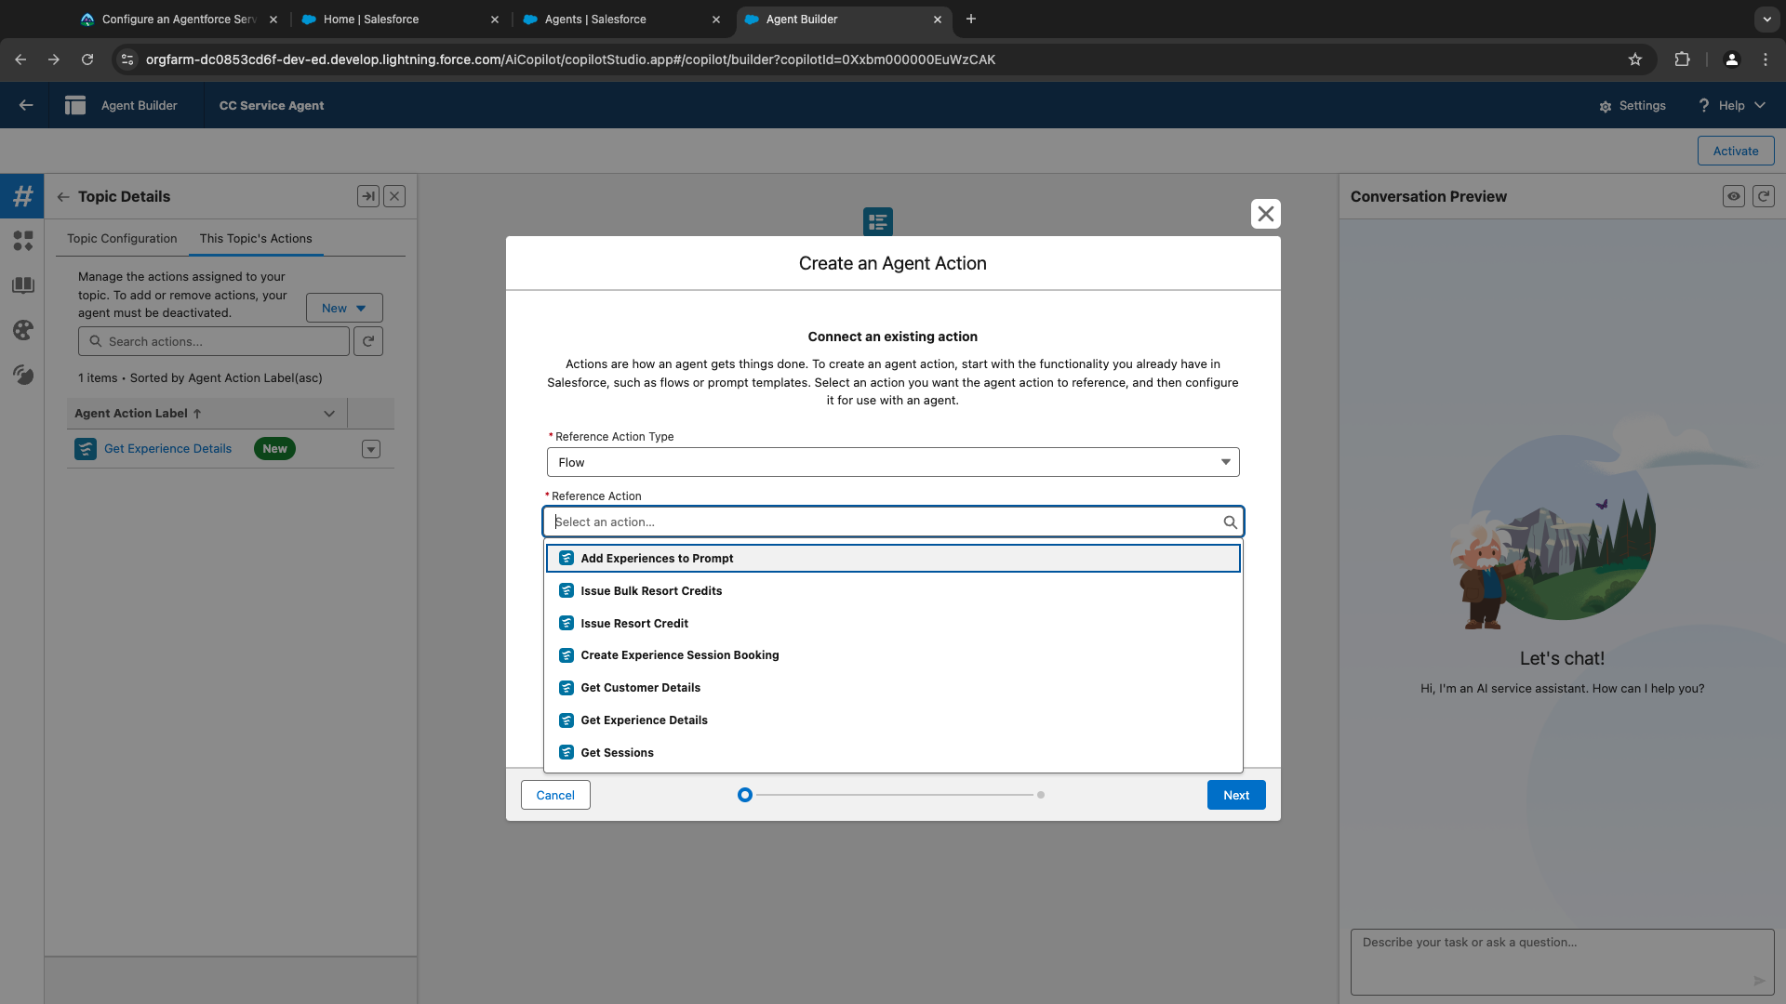

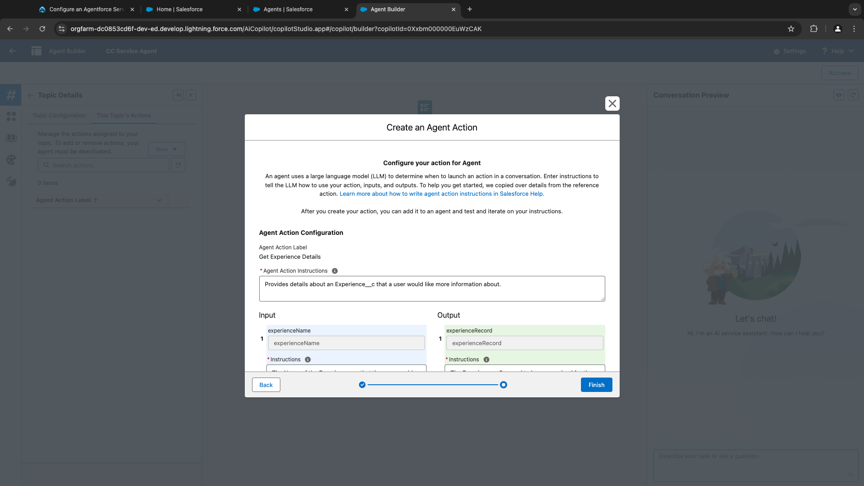

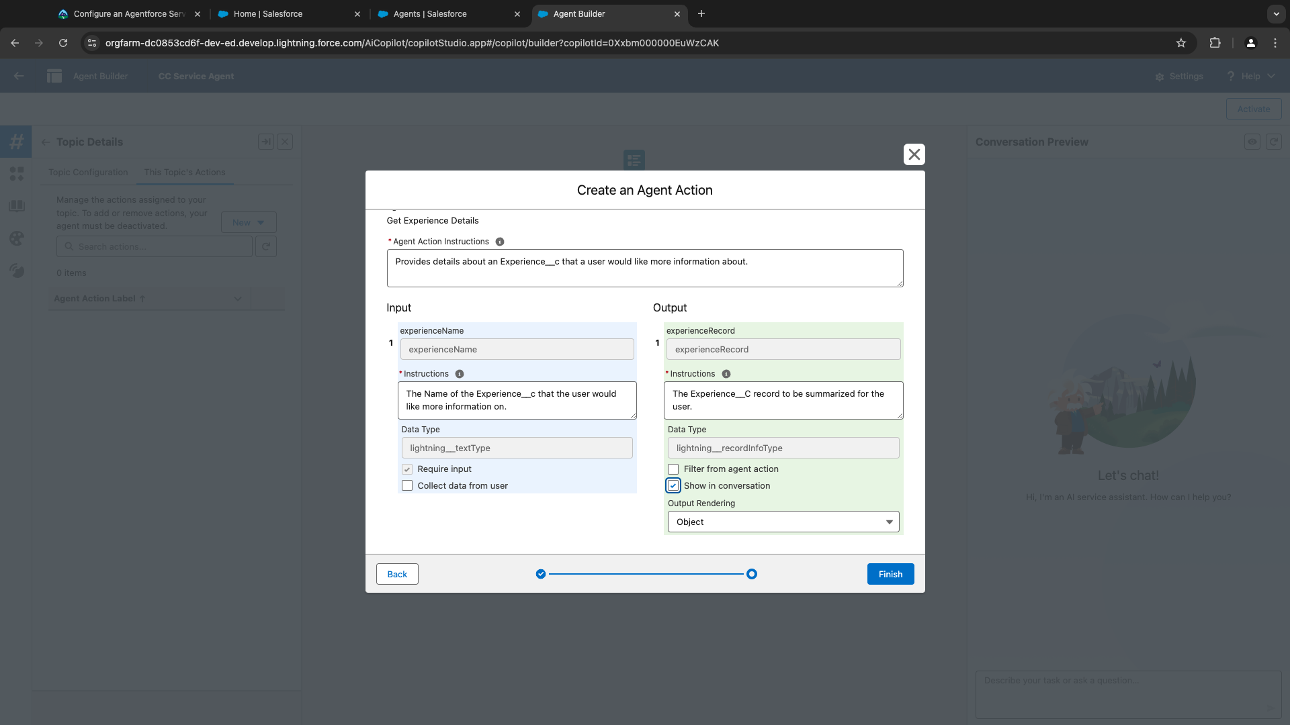

Prompt Template – Add action

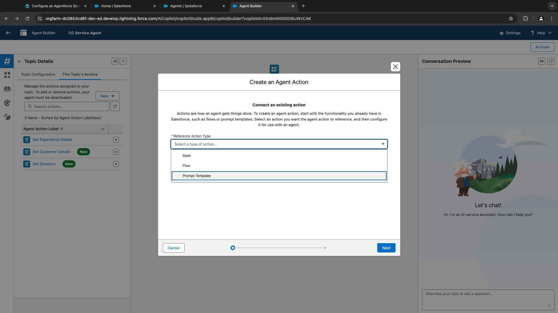

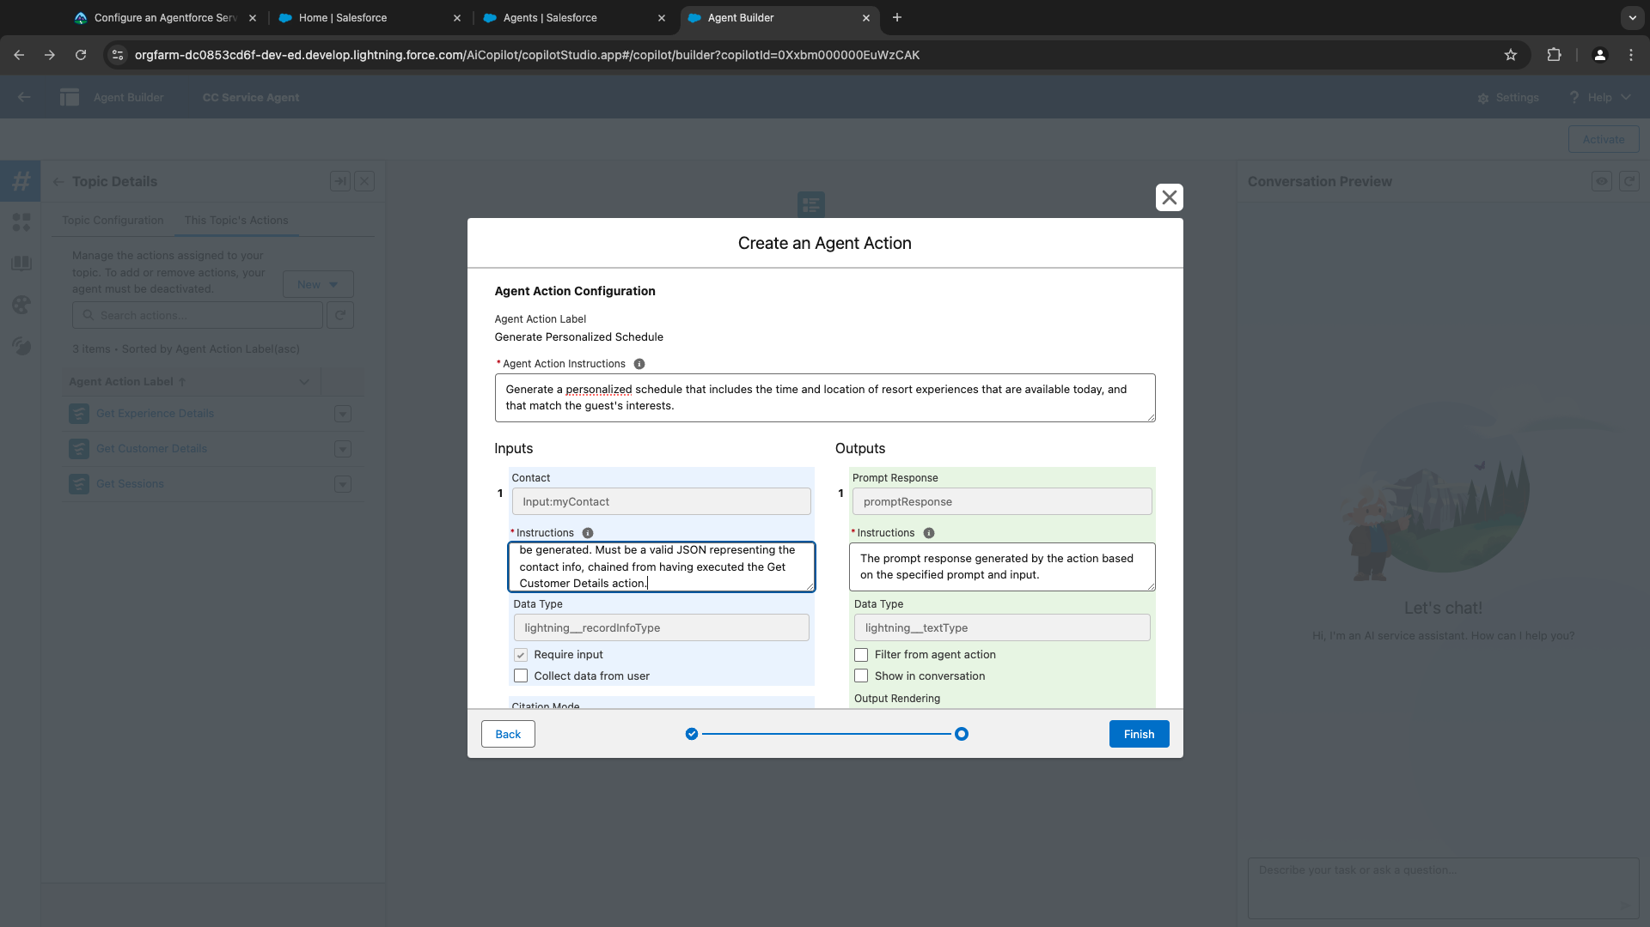

Adding instructions for agents:

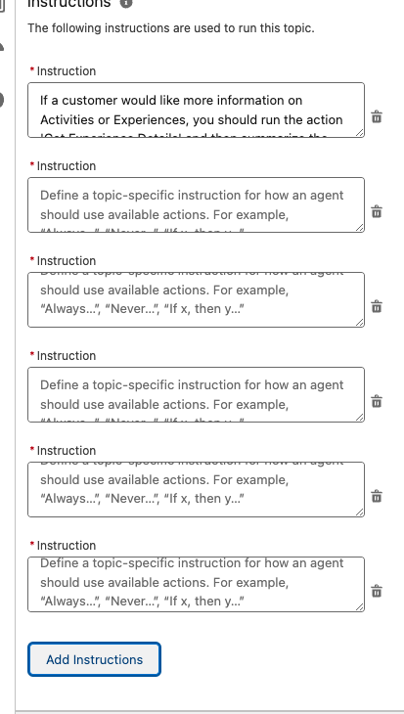

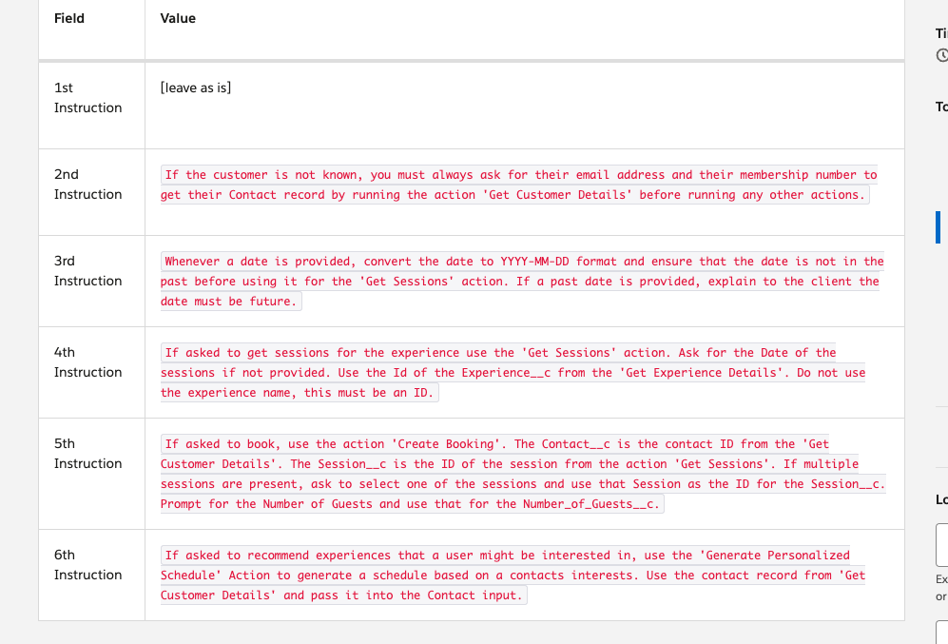

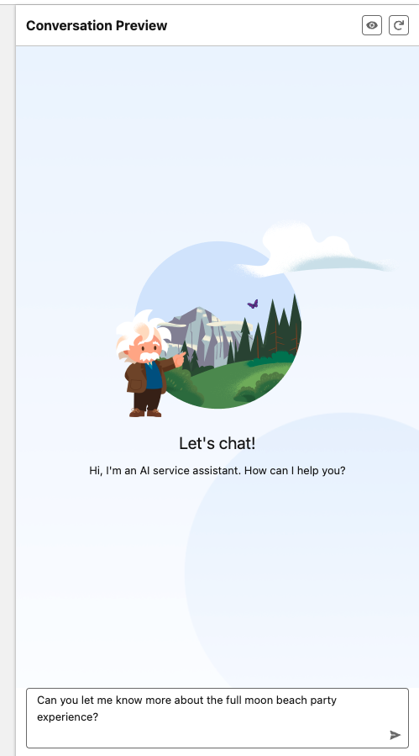 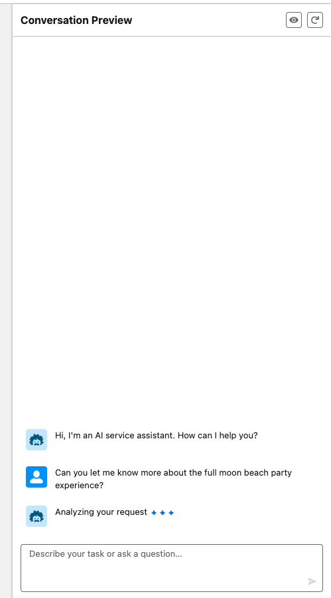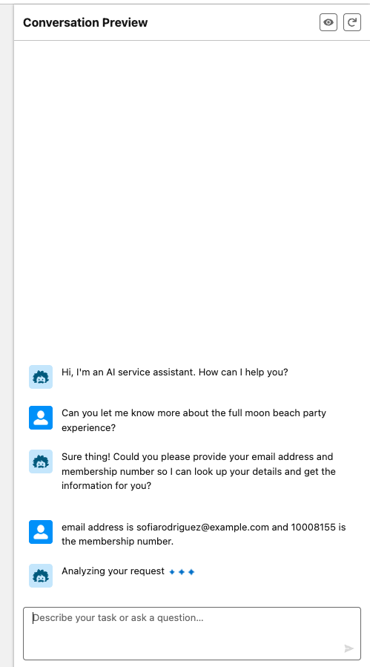 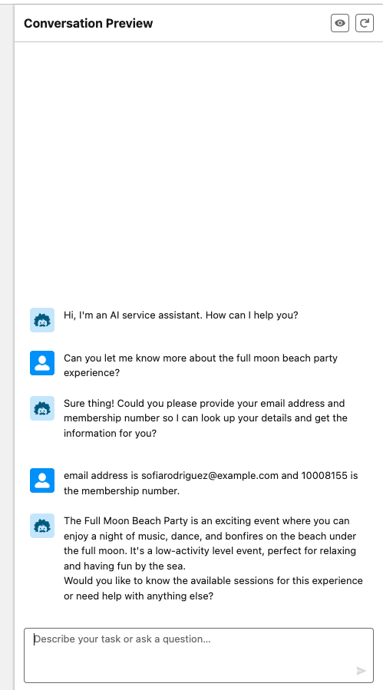 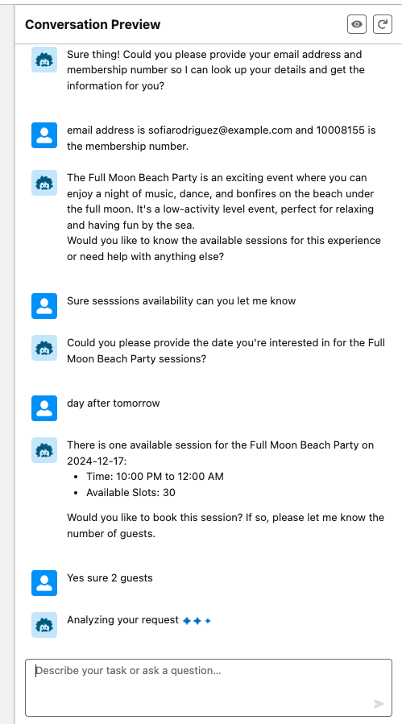 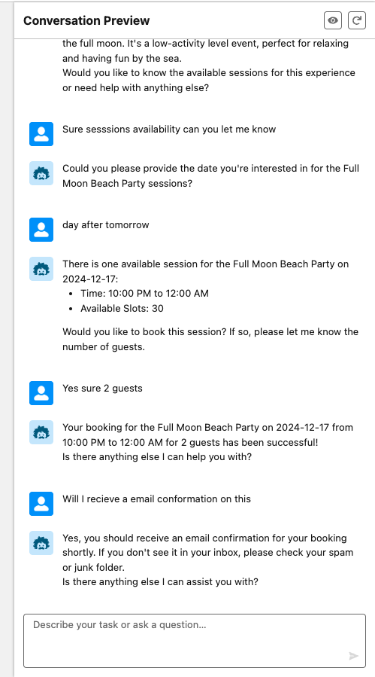

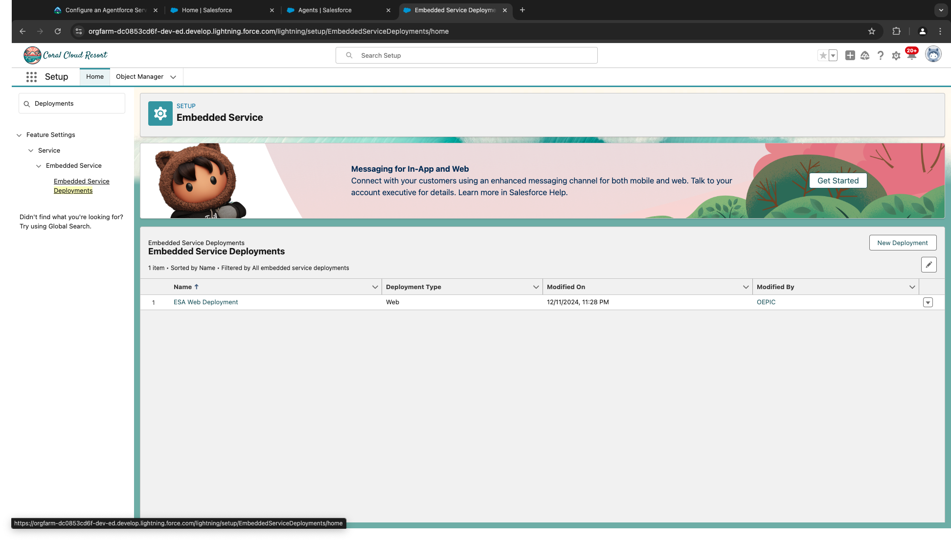

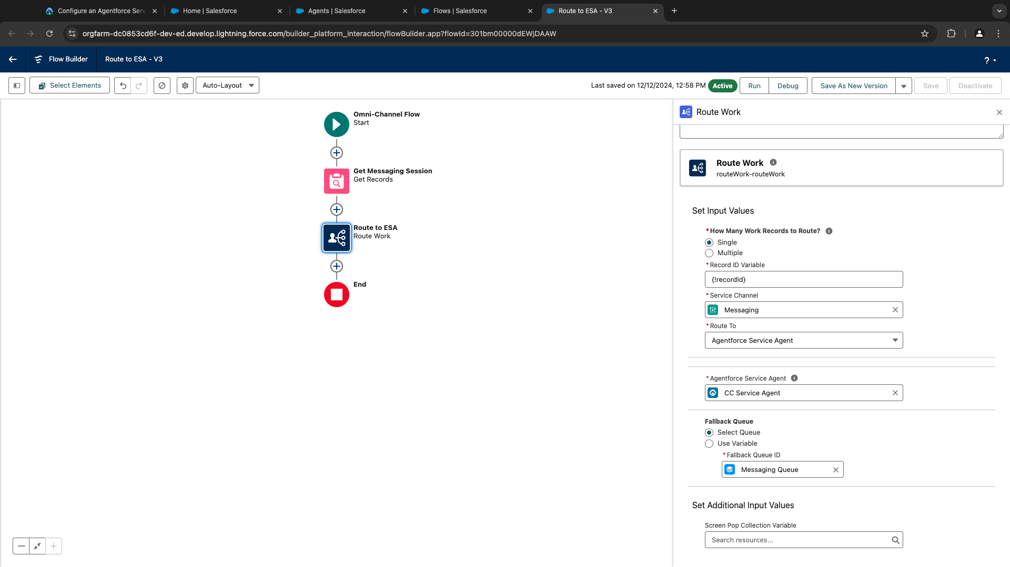

Publish and test

